

* INTERNET OF THINGS

PROJECT NAME : INTELLIEGENT OF CARGO MANAGEMENT SYSTEM

TEAM MEMBERS :

V.SOWMYA

V.SRAVANI

R.BHUPAL

**TITLE OF THE PROJECT** :

**INTELLIGENT OF CARGO MANAGEMENT SYSTEM USING INTERNET OF THINGS**

INTRODUCTION:

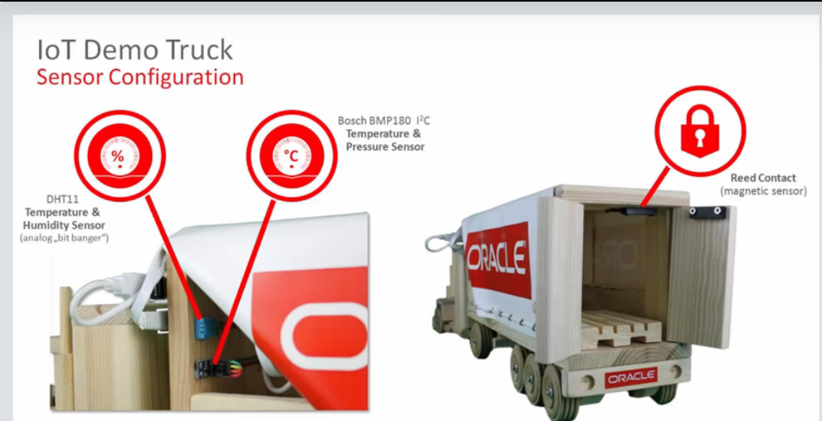

 Cargo Manager is a comprehensive cargo managementmodule, designed for addressing the areas of General cargo, Bulkcargo operations. All the aspects of cargo like documentationhandling, movement, and storage are addressed in this module

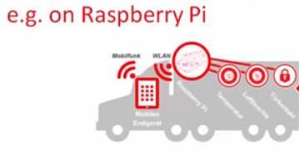

**Key Features Include**

* General cargo booking(manifestation of cargo)
* Storing of cargo (actual cargo weight , volume etc. Are recorded)
* Generating the gate pass for bringing the cargo into the warehouse
* Marking the truck exit.
* Delivery order for rejected or damaged cargo
* Generating gate pass for maintenance i.e.,moving the cargo from one place one to another.
* Extensive report and querying facilities
* Creation of master like cargo agents,commodity master.

# Project Description

Supply Chain Management consists of a number of phases in which the transportation plays an important role. The perishable products are to be delivered at the desirable quality in the right time. The lack of constant monitoring of the product during the freight contributes towards the food wastage during the transportation phase. The various factors that influence the freshness scale of the product which includes the natural and physical conditions are to be considered before the movement of the goods from the source to the destination.

The sensors are deployed inside the truck to monitor the freshness of the product. Various parameters like temperature, humidity and the air quality inside the truck are monitored. An app is designed for receiving all the parameters through Bluetooth communication. If the freshness level falls below the scale, then an SMS is sent to authorized person with the location of truck.

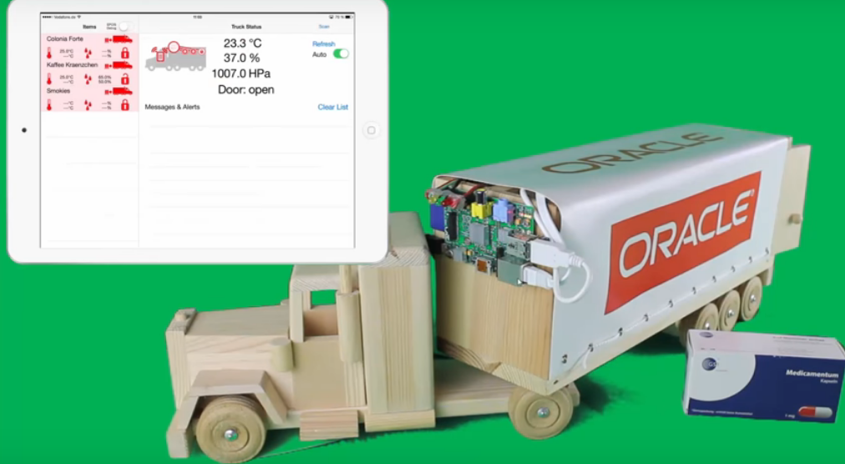

HARD WARE COMPONENTS :

- DHT11 SENSOR

- RASPBERRY PI

- MQ135

- LED

SOFTWARE COMPONENTS :

- ANDROID (MIT APP INVENTOR)

- WIFI

s

BLOCK DIAGRAM :

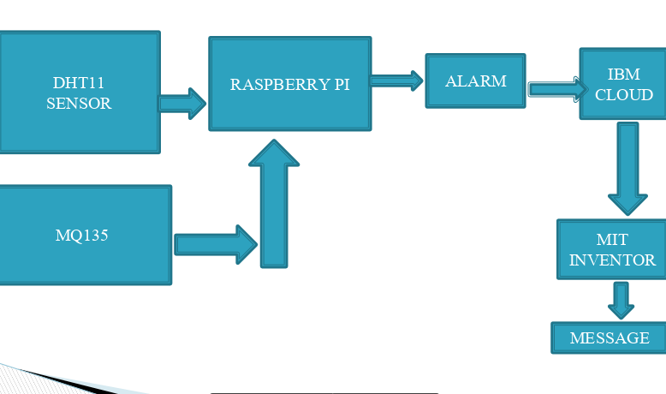

**DEFINING EACH HARDWARE COMPONENT :**

**DHT11-SENSOR** :

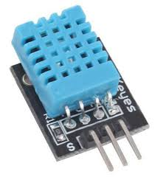

HUmidity sensors detect the relative humidity of the immediate environments in which they are placed. They measure both the moisture and temperature in the air and express relative humidity as a percentage of the ratio of moisture in the air to the maximum amount that can be held in the air at the current temperature. As air becomes hotter, it holds more moisture, so the relative humidity changes with the temperature.

Most humidity sensors use capacitive measurement to determine the amount of moisture in the air.

### Hardware Connections

The Humidity sensor module has 3 pins.The following connections should be made to connect the sensor module with Arduino.

* + to 5V
* - to Gnd
* Out to Analog 0 pin of Arduino

**CODE FOR DHT11 SENSOR** :

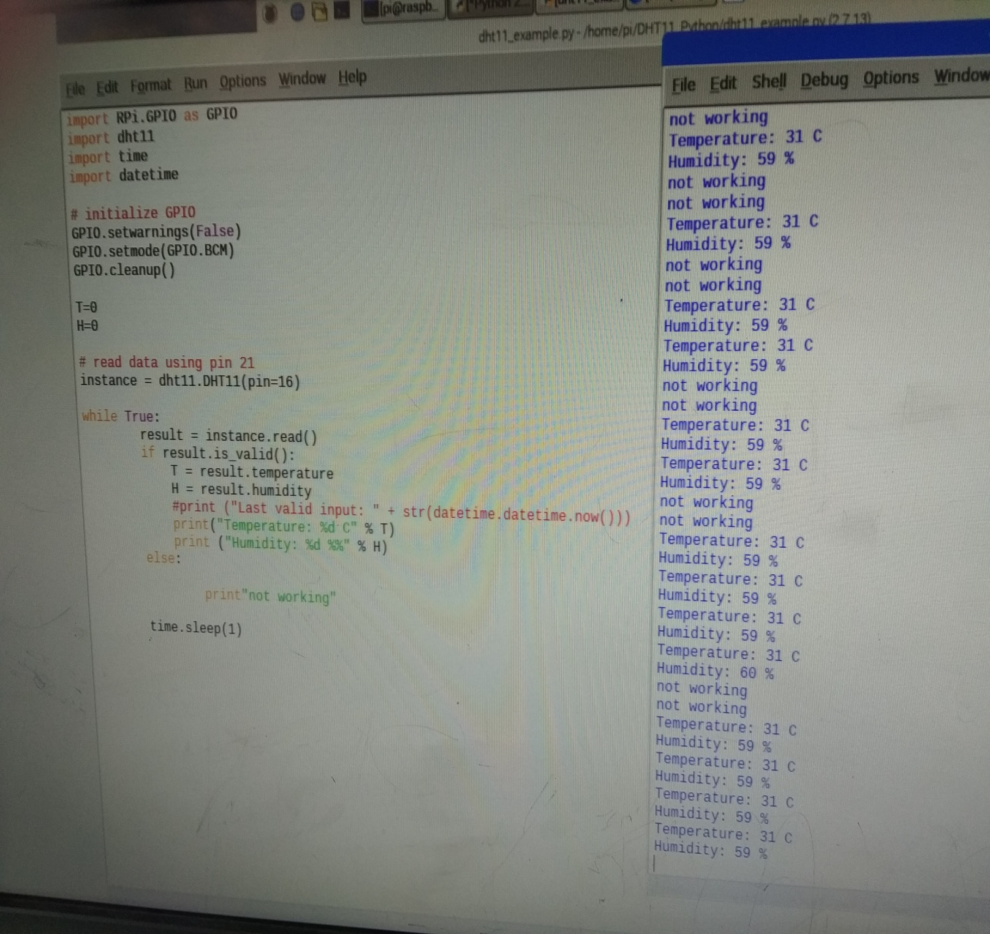

**Related Links**

* [**DHT11Lib**](http://playground.arduino.cc/Main/DHTLib)
* [**Using a DHTxx Sensor**](https://learn.adafruit.com/dht/using-a-dhtxx-sensor/)
* [**Using the DHT11 Temperature & Humidity sensor with an Arduino - Tutorial**](https://www.youtube.com/watch?v=OogldLc9uYc/)
* [**Humidity sensor DHT11**](http://hetpro-store.com/TUTORIALES/sensor-dht11/)

**MQ135 Module** :

* . The material of MQ135 is SnO2, it is a special material: when exposed to the clean air, it is hardly being conducted, however, when put it in an environment with combustible gas, it has a pretty performance of conductivity. Just make a simple electronic circuit, convert the change of conductivity to a correspond output signal. MQ135 gas sensor is sensitive to Ammonia, Sulfide, Benzene steam, smoke and other harmful gases. Used for family, surrounding environment noxious gas detection device, apply to ammonia, aromatics, sulfur, benzene vapor, and other harmful gases/smoke, gas detection, tested concentration range: 10 to 1000ppm.

**MQ135 MODULE**

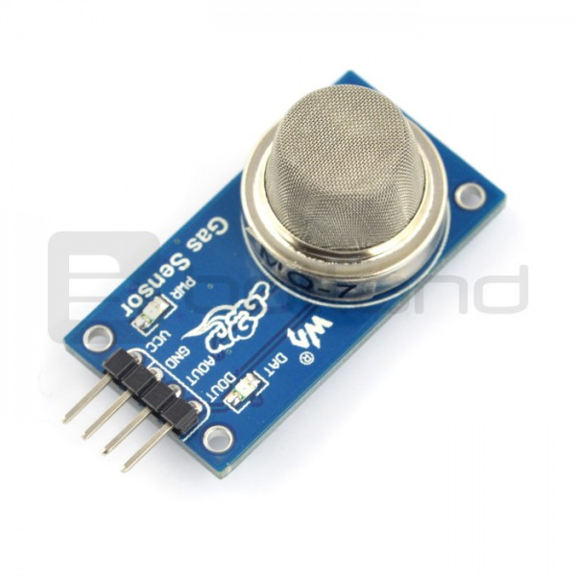

**TECHNICAL DATA :**

Input voltage: DC 5V

Current: 150mA

Digital Output: TTL 0 is 0.1V and TTL 1 is 5V

Analog Output: 0.1 to 0.3V (it seems that there’s almost no pollution), when harmful gas’ concentration reach max, analog output will become 4V

Tip: MQ5 sensor module needs about 20s to preheat, measuring data will be stable in this way, by the way, sensor module will heat.

**Symbol**        **Detect Gas**                      **Detect Concentration**

MQ-2          combustible gas                  300-10000ppm

                   Smoke, hydrogen

                   propane

MQ-5          LPG, natural gas                  300-10000ppm

                              Town gas

MQ-135        Carbon oxide, coal gas        300-10000ppm

**Features**

Working voltage: DC 5V

Working Current: 150mA

DOUT: TTL output

AOUT: Analog output

Preheat time: Over 20s

Dimension: 32mm x 22m x 27mm (HIGH 27mm)

low cost

suitable to any application

sensor module needs 20s to preheat, or the measuring data won’t be stable.

CODE FOR MQ135 :

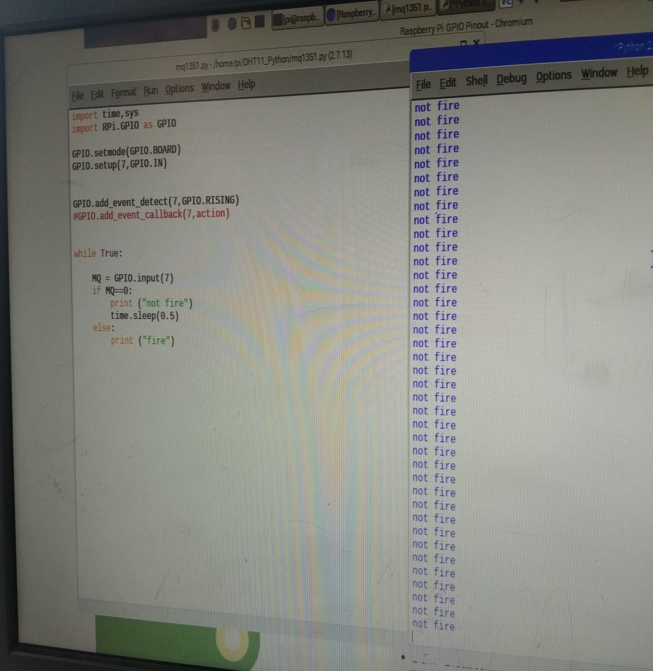

Raspberry pi :

- The **Raspberry Pi** is a series of small [single-board computers](https://en.wikipedia.org/wiki/Single-board_computer) developed in the [United Kingdom](https://en.wikipedia.org/wiki/United_Kingdom) by the [Raspberry Pi Foundation](https://en.wikipedia.org/wiki/Raspberry_Pi_Foundation) to promote teaching of basic [computer science](https://en.wikipedia.org/wiki/Computer_science) in schools and in [developing countries](https://en.wikipedia.org/wiki/Developing_countries).[[5]](https://en.wikipedia.org/wiki/Raspberry_Pi#cite_note-5)[[6]](https://en.wikipedia.org/wiki/Raspberry_Pi#cite_note-6)[[7]](https://en.wikipedia.org/wiki/Raspberry_Pi#cite_note-7) The original model became far more popular than anticipated,[[8]](https://en.wikipedia.org/wiki/Raspberry_Pi#cite_note-1000x-8) selling outside its [target market](https://en.wikipedia.org/wiki/Target_market) for uses such as [robotics](https://en.wikipedia.org/wiki/Robotics). It does not include peripherals (such as [keyboards](https://en.wikipedia.org/wiki/Keyboard_(computing)) and [mice](https://en.wikipedia.org/wiki/Mouse_(computing))) and [cases](https://en.wikipedia.org/wiki/Computer_case).[[8]](https://en.wikipedia.org/wiki/Raspberry_Pi#cite_note-1000x-8)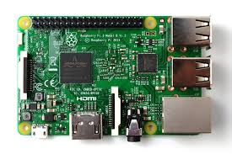

|  |  |
| --- | --- |
| [**Operating system**](https://en.wikipedia.org/wiki/Operating_system) | [Windows 10 IoT Core](https://en.wikipedia.org/wiki/Windows_10_editions#Device-specific_editions)[[2]](https://en.wikipedia.org/wiki/Raspberry_Pi#cite_note-auto-2) |
| [**System-on-chip**](https://en.wikipedia.org/wiki/System_on_a_chip)**used** | [Broadcom](https://en.wikipedia.org/wiki/Broadcom) BCM2837B0 |
| [**CPU**](https://en.wikipedia.org/wiki/Central_processing_unit) | 1.4 [GHz](https://en.wikipedia.org/wiki/Hertz) [64](https://en.wikipedia.org/wiki/64-bit_computing)/32-bit [quad-core](https://en.wikipedia.org/wiki/Multi-core_processor) [ARM Cortex-A53](https://en.wikipedia.org/wiki/ARM_Cortex-A53) |
| **Memory** | 1 [GB](https://en.wikipedia.org/wiki/Gibibyte) [LPDDR2](https://en.wikipedia.org/wiki/Mobile_DDR#LPDDR2) [RAM](https://en.wikipedia.org/wiki/Random-access_memory) at 900 MHz[[3]](https://en.wikipedia.org/wiki/Raspberry_Pi#cite_note-3) |
| **Storage** | [MicroSDHC](https://en.wikipedia.org/wiki/MicroSDHC) slot |
| **Graphics** | [Broadcom](https://en.wikipedia.org/wiki/Broadcom) [VideoCore](https://en.wikipedia.org/wiki/VideoCore) IV 300 MHz/400 MHz |
| **Power** | 1.5 W (average when idle) to 6.7 W (maximum under stress)[[4]](https://en.wikipedia.org/wiki/Raspberry_Pi#cite_note-:1-4) |
| **Website** | [raspberrypi.org](https://raspberrypi.org/) |

## External links[[edit](https://en.wikipedia.org/w/index.php?title=Raspberry_Pi&action=edit&section=39)]

* [Raspberry Pi Foundation official website and forums](https://www.raspberrypi.org/) [Edit this at Wikidata](https://www.wikidata.org/wiki/Q245#P856)
* [Raspberry Pi Wiki, supported by the RPF](https://elinux.org/RaspberryPiBoard)
* [The MagPi newsletter](http://www.themagpi.com/)
* [Raspberry Pi pinout](https://www.panu.it/raspberry/) – board GPIO pinout
* [Raspberry Pi component map](http://raspmap.everpi.net/)
* [RaspberryPi Boards: Hardware versions/revisions](https://elinux.org/RaspberryPi_Boards)
* [ARM1176JZF-S (ARM11 CPU Core) Technical Reference Manual](http://infocenter.arm.com/help/topic/com.arm.doc.ddi0301h/DDI0301H_arm1176jzfs_r0p7_trm.pdf), ARM Holdings.
* [Raspberry Pi Forum Community](https://www.raspberrypi.org/forums/)

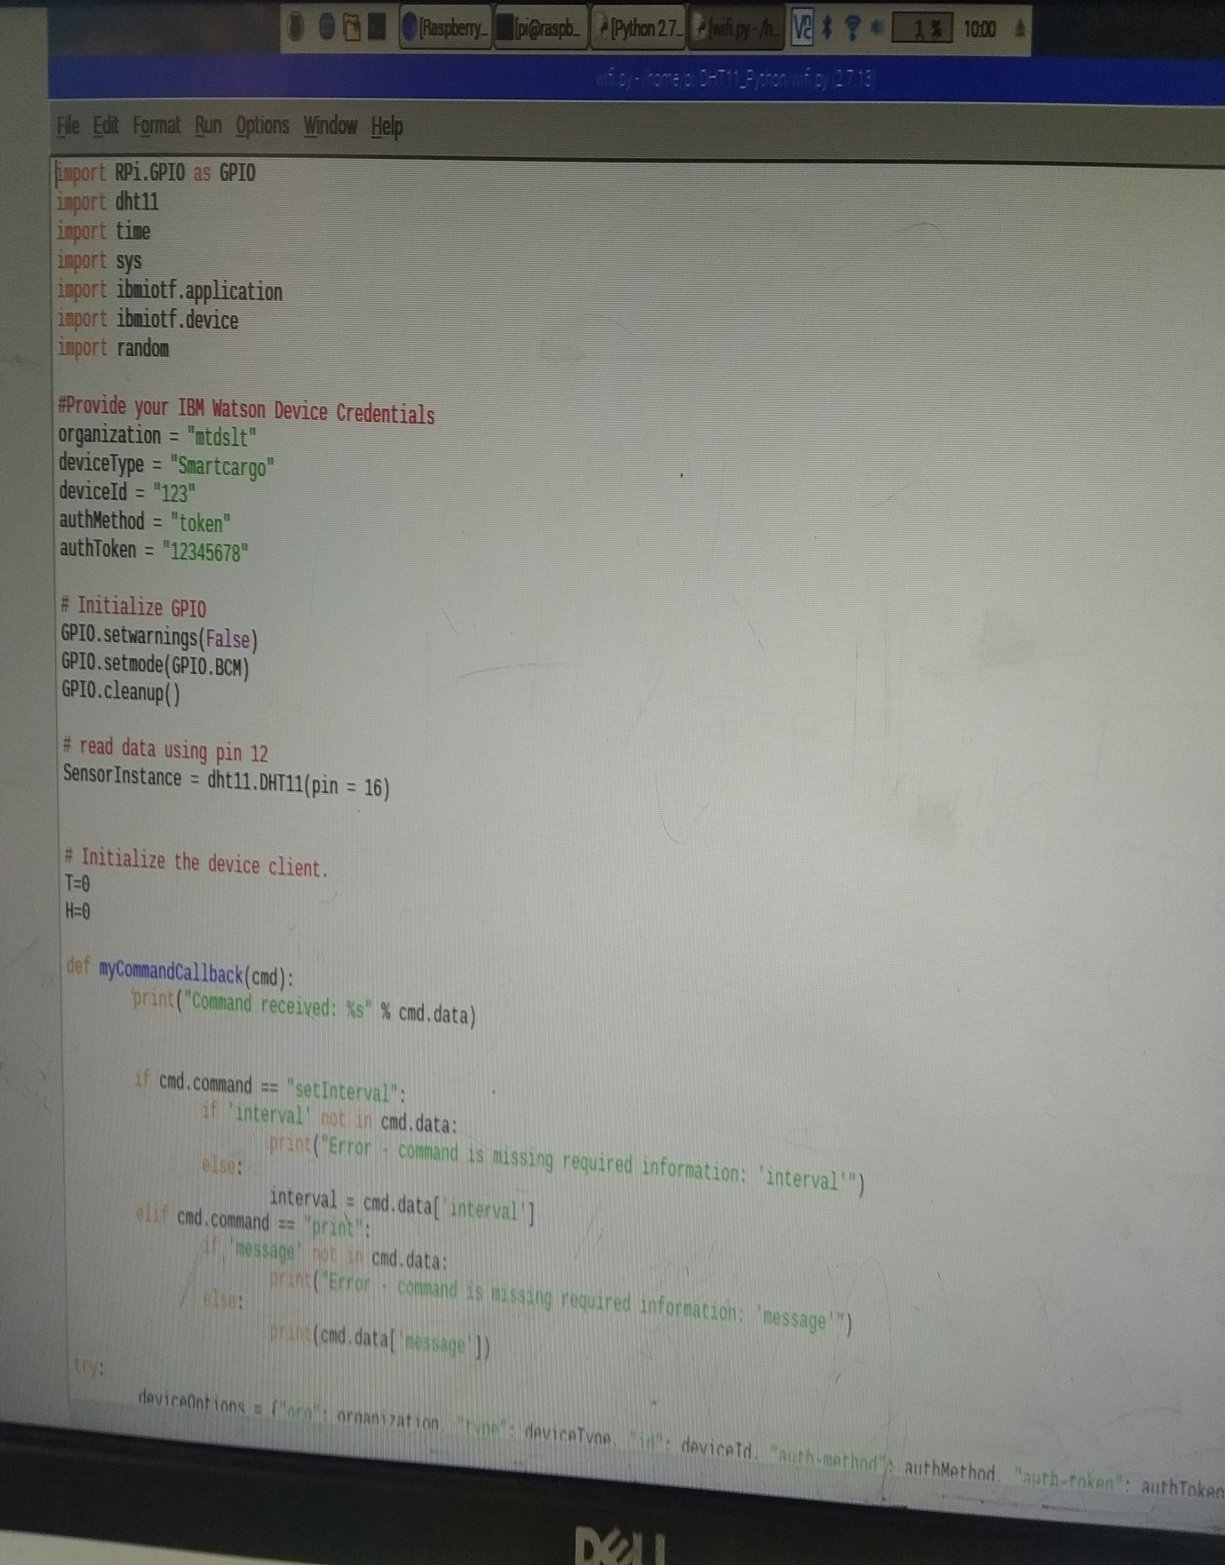

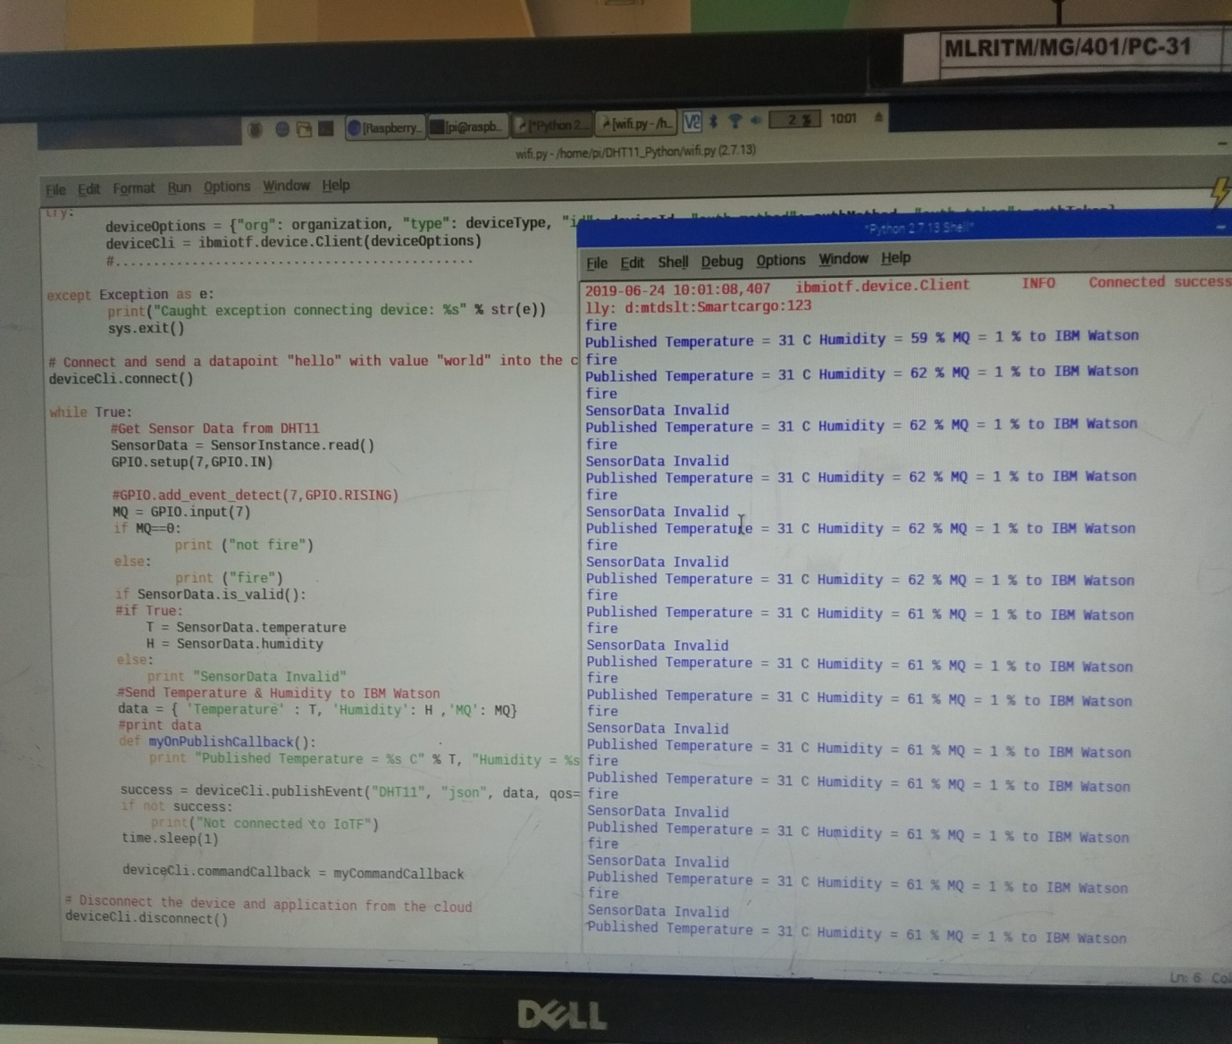

**Advantages of cargo management system :**

-Manipulation of cargo can be easily tracked.

-Cargo will be in surveillance during the transition between source and destination.

**DISADVANTAGES:**

-Internet connectivity is mandatory.

**Conclusion :**

In this project we have implemented an intelligent cargo system for efficient tranporatation of goods from z givej source to destination. The sensors are simulated using the route map . the most preferential route is taken in order to effectively maintain the state of the product in the desirable state. Simulation is used to generate the trajectories of a route . As future work real time situations like traffics , truck breakdown and catastrophic effects can be considerable in order to improve the results.

THANK YOU